Equalized Noise Generator
Version 1.0.0

Welcome
Thank you for downloading this fine plug-in. Equalized Noise Generator is a standalone tool for generating equalized noise independently for 2 separate channels.
In order to get the most out of the Equalized Noise Generator, please spend a few moments reading this brief manual.

License
The pre-compiled Equalized Noise Generator has a very simple license:

- Equalized Noise Generator is freeware. This means that you are free to use this application in any context. Also you are free to share it on a personal base (ie. give it to friends). However, only the entire unaltered archive, including this document, may be shared. Public redistribution is only allowed on request.
- Copyright of the code and the pre-compiled plug-in remain property of the Delphi ASIO & VST Project and namely Christian-W. Budde.
- This plug-in is provided at no cost; therefore the author Christian-W. Budde assume no responsibility for any negative effects that may occur to the end user or the equipment used to run the software.
Select ASIO Driver
Open ASIO Control Panel
Left Gain for 20 Hz
(-15 dB..+15 dB)
Right Gain for 320 Hz
(-15 dB..+15 dB)
Start Audio Processing
- Magazine editors are welcome to include the plug-in on cover mount discs or similar media; However, it is mandatory to inform the author Christian-W. Budde about this. A copy of the publication is always appreciated, but not expected.

User Interface
The user interface shows a control to select, configure and start the ASIO driven sound processing on top and two filter banks for the left and right channel on the bottom. The filter banks are using a fixed frequency setup with fixed bandwidth. Only the gain of the filters is adjustable using the dedicated sliders.
Here is a commented screenshot:

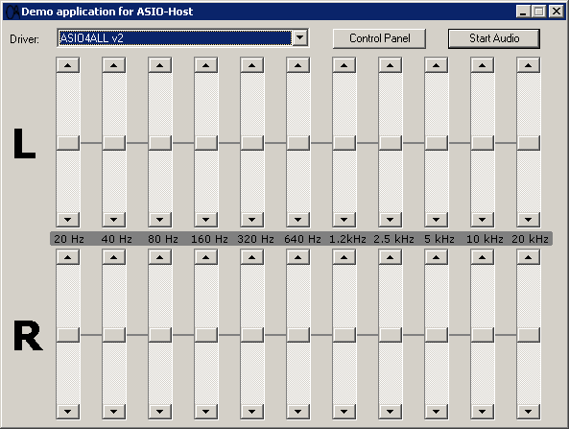

Feedback / Bug Reports
I am always eager to hear feedback or have bugs reported. The easiest
way is to send me a mail to: Christian@aixcoustic.com

Furthermore feel free to download the source code, that can be found in the Delphi ASIO & VST Project at sourceforge.net.

Version History
  - First release!

Credits

• Programming: Christian W. Budde
• Documentation based on a template by Greg Pettit

ASIO name and technology © Steinberg GmbH
The ASIO logo is a trademark of Steinberg GmbH

